# Weekly Report

**Work done in last week ( Attach supporting Documents):**

1. **Tkinter**
2. **Pillow(PIL)**

**1. Tkinter :-**

Tkinter is the standard GUI library for Python. Python when combined with Tkinter provides a fast and easy way to create GUI applications. Tkinter provides a powerful object-oriented interface to the Tk GUI toolkit. Import the Tkinter module.

Creating a GUI application using Tkinter is an easy task. All you need to do is perform the following steps −

* Import the Tkinter module.
* Create the GUI application main window.
* Add one or more of the above-mentioned widgets to the GUI application.
* Enter the main event loop to take action against each event triggered by the user.

It consist of 15 types of widgets some of there are Button, Canavas , Frame , Entry , Label , Menu , Message and many more.

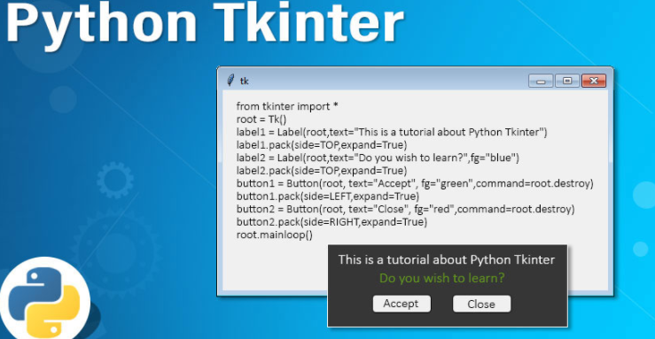

**2. Pillow(PIL):-**

* **pip install Pillow**(Command to install python library)
* The Python Imaging Library adds image processing capabilities to your Python interpreter.
* This library provides extensive file format support, an efficient internal representation, and fairly powerful image processing capabilities.
* The core image library is designed for fast access to data stored in a few basic pixel formats. It should provide a solid foundation for a general image processing tool.
* Supports Image Archieve we can convert image from one format to another and can print.



**Related to PROJECT :-**

* As we Know that Tkinter is GUI library in python so we have used this library in our project by importing the library we will set the frame rates in our project according to its needs .
* With the help of Tk GUI kit we will make this smart cctv application which will contain modules like in and out , monitor , record .
* We are implementing pillow in our project as it is a free and open-source additional library for the Python programming language that adds support for opening, manipulating, and saving many different image file formats.

**Reason for incomplete work:**

* Working on Pillow and Tkinter implementing in our project.

**Plans for next week:**

* Making GUI for our application Smart CCTV by using python tkinter .

## References:

* https://www.tutorialspoint.com/python/python_gui_programming.htm#:~:text=Tkinter%20is%20the%20standard%20GUI,to%20the%20Tk%20GUI%20toolkit.&text=Import%20the%20Tkinter%20module.
* https://pypi.org/project/Pillow/
* https://www.tutorialspoint.com/python_pillow/

## Signature of External Guide Signature of Internal Guide